BOOKING CONTACT INFORMATION  Meeting title: ….……………………………………………  ……………………………………………………………………..  Company name: …………………………………………..  ……………………………………………………………………..  Name: .............................................................  Position: ..........................................................  Address: ..........................................................  ..................................................................................................................................................  Postcode: ........................................................  E-mail address: ...............................................  Contact number: …………………………………………. |  |  |  |  |  |  | INVOICING INFORMATION  Name: ............................................................  Position: .........................................................  Address: .........................................................  ................................................................................................................................................  Postcode: .......................................................  E-mail address*: ............................................  Contact number: …………………………………………  Purchase order: ………………………………………….  *This is required for invoicing purposes
DATE FROM | DATE  TO |  | TIME  FROM | TIME  TO |  | NUMBER ATTENDING |  |  |  | ROOM  NAME |  | LAYOUT  OPTION
Rooms available for hire and layout choices for reference
There is Wi-Fi available in all rooms
The St Magnus Suite
The Grainayre
The Noust
Quayside (Studio 1)
Studio 2
Leisure Pool Viewing Gallery
Phoenix Cinema
U-Shape  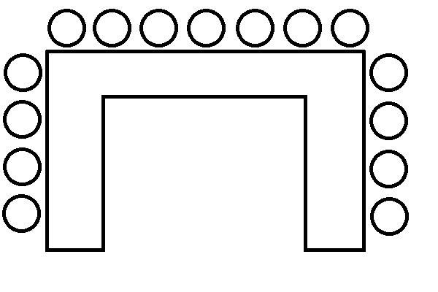 |  | Theatre |  |  | Classroom  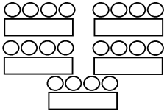 |  |  | Boardroom  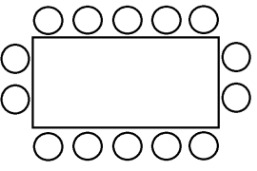 |  |  | Cabaret
Equipment available for hire
If you choose to use your own equipment it is your responsibility to check that it is compatible with our equipment. A member of our operational team will be able to help with this if required.
Equipment |  |  |  |  |  |  |  |  | Number Required
Laptop (3 available)
LCD projector (3 available)
LCD projector screen (5 available)
Flipchart with paper and pens
ADDITIONAL INFORMATION

Please give full details of any further set-up requirements you may have, and list any catering you require (including serving times).
Please note, our café staff require confirmed numbers and catering choices a minimum of 7 days before the date of your booking.
............................................................................................................................................................................................................................................................................................................................................................................................................................................................
............................................................................................................................................................................................................................................................................................................................................................................................................................................................
....................................................................................................................................................
....................................................................................................................................................
COVID OFFICER
Does your organisation have a COVID Officer? Please circle: Yes / No
CO name: …..…………………….……….……… CO contact no.: …………………………………….……..
Copies of documentation are required to be held on file

DECLARATION
I have read and understood the conditions of hire and agree to abide by them.
I will not assume that by submission of this application form, my booking will be accepted.
I agree that this application is provisional, subject to available facilities, until I receive a booking confirmation sheet from The Pickaquoy Centre Trust.
I understand that if I cancel with less than 24 hours’ notice, I will be charged in full.

Signed: ..................................................................
Print: …………………………………………………………………………….
Date: ………./………./……….

Please return your completed form to: Bookings@pickaquoy.com

Please note that your booking is only confirmed when you have received a booking confirmation from the Centre.

ATTENDANCE NUMBERS
In order to provide accurate centre usage figures to Orkney Islands Council, we request that attendance figures are sent to us. These figures need to be split into U18’s and 18+, and emailed to Bookings@pickaquoy.com after your booking has taken place please.

PAYMENT TERMS
• The Pickaquoy Centre Trust operates a 30 day payment term policy
• Invoices are issued at the end of every month and statements are emailed on a weekly basis – please check your ‘junk box’ regularly. If you have a query regarding your invoice and/or statement please contact a member of the Bookings Team as soon as possible: Bookings@pickaquoy.com
• No further bookings will be accepted until your account balance is cleared.

Please return the completed booking form to: bookings@pickaquoy.com

All bookings are only confirmed when you receive a confirmation sheet from a member of the Bookings team.

